Filters and JQL: Advanced Search for Better Visibility
1. Using Basic Search and Quick Filters in Jira
1.1 Basic Search (Issue Navigator)
Basic Search allows users to find issues without writing queries using dropdown selections.
Common Filters in Basic Search:
- Project
- Issue Type
- Status
- Assignee
- Priority
- Labels

Hands-On Lab: Basic Search
- Click Filters → View all issues
- Ensure Basic mode is selected
- Select:
  - Project = M First
  - Status = In Progress
- View filtered results instantly
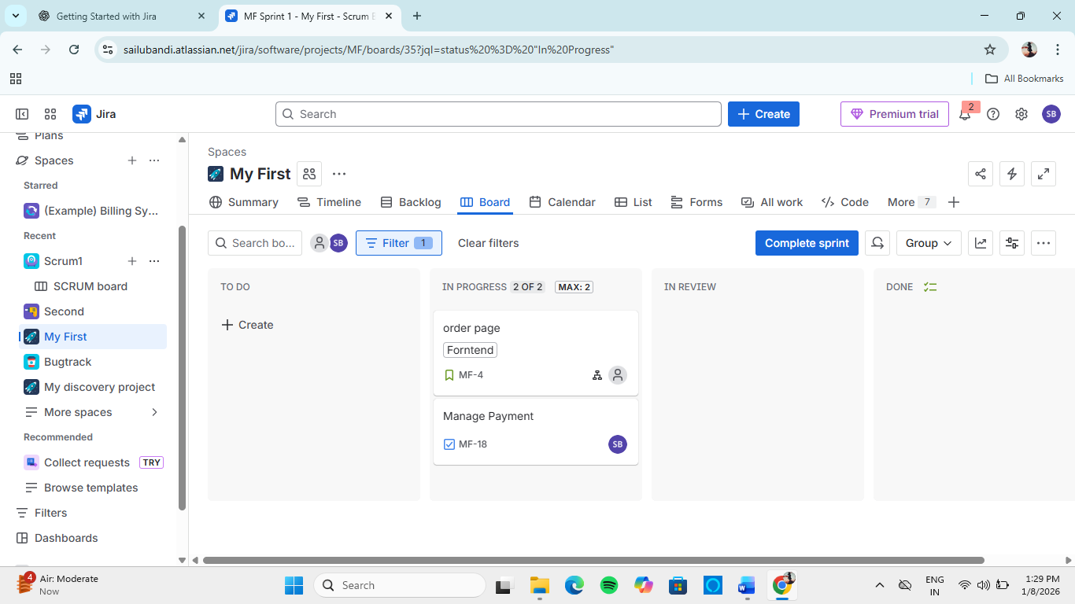

1.2 Quick Filters (Board Level)
Quick Filters are one-click filters applied directly on Scrum or Kanban boards.
Examples:
- My Issues
- High Priority
- Bugs Only

Hands-On Lab: Use Quick Filters
- Open your Board
- Click an existing Quick Filter
- Observe board update in real time
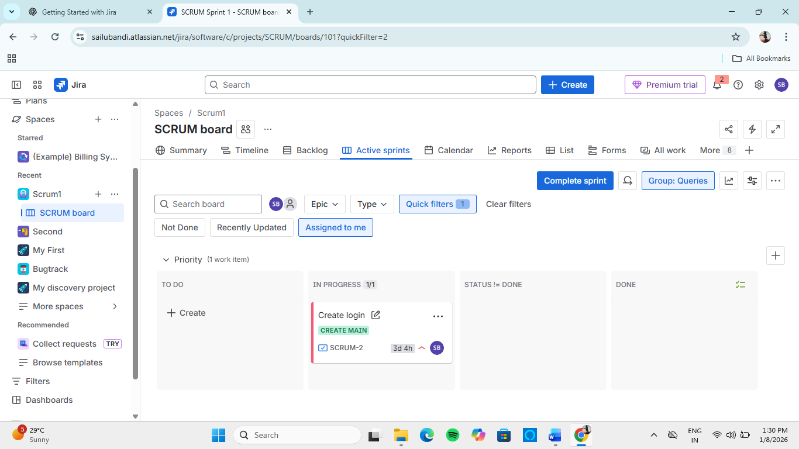

2. Creating and Saving Filters in Jira
Saved Filters allow quick reuse of frequently used searches.

Hands-On Lab: Create and Save a Filter
- Go to Filters → View all issues
- Apply required conditions
- Click Save As
- Name filter: High Priority Bugs
- Save
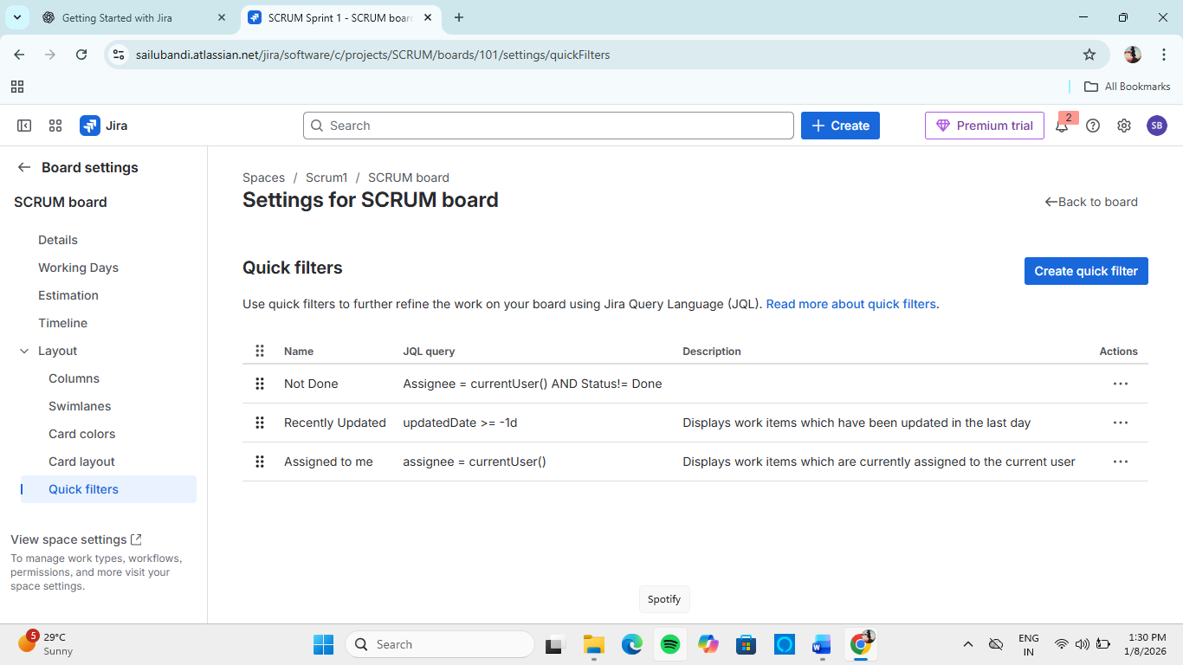

Benefits of Saved Filters
- Quick access to important work
- Can be shared with team
- Used in dashboards and reports

3. JQL Basics: Jira Query Language
3.1 What is JQL?
JQL (Jira Query Language) is a powerful query language used to search issues precisely.
JQL allows searching Jira like SQL but for issues.

Why JQL Matters
- Advanced filtering
- Accurate reporting
- Automation triggers
- Dashboard gadgets

Basic JQL Syntax
field operator value

Common JQL Fields
Field | Example
project | project = ABC
status | status = Done
assignee | assignee = currentUser()
priority | priority = High

Hands-On Lab: Switch to JQL
- Open Issue Navigator
- Click Switch to JQL
- Enter:
project = ABC AND status = "In Progress"
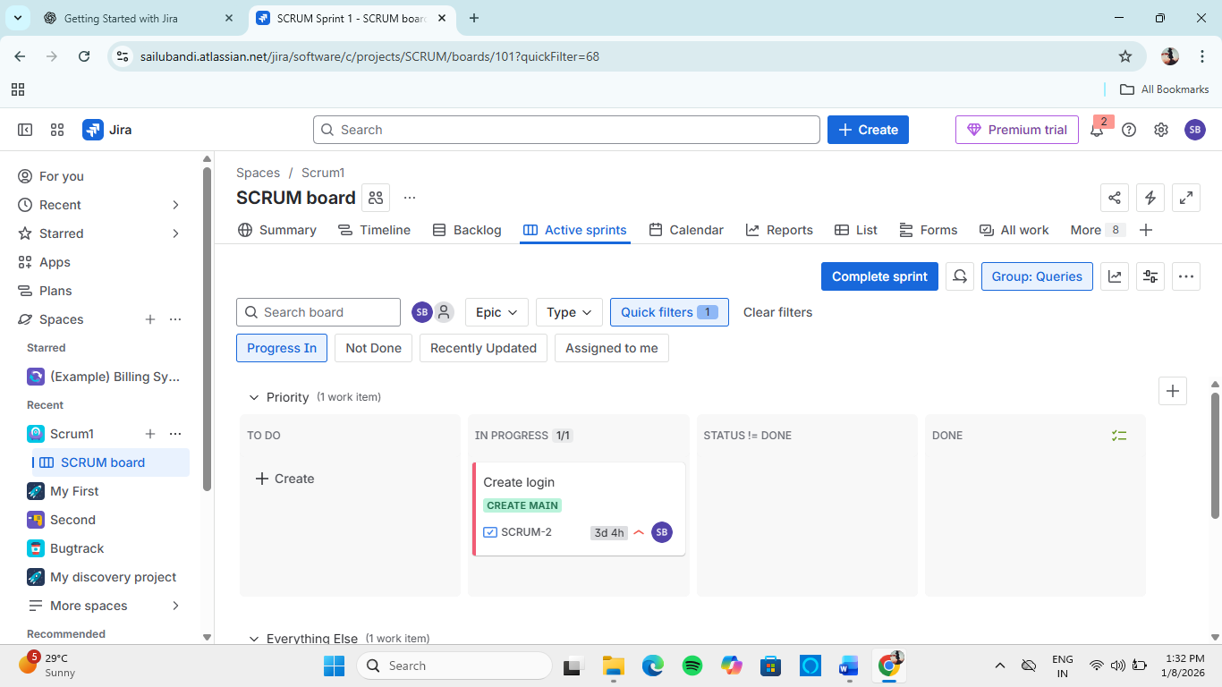

4. Time-Based JQL Queries
Time-based queries help track recent work, delays, and progress trends.

Common Time Fields
- created
- updated
- resolved
- due

Example Time-Based Queries
created >= -7d
➡ Issues created in last 7 days
updated >= startOfWeek()
➡ Issues updated this week
due < now()
➡ Overdue issues

Hands-On Lab: Time Query
- Switch to JQL
- Enter:
project = ABC AND created >= -30d
- Analyze recent issues

5. Link-Based and Hierarchy JQL Queries
5.1 Link-Based Queries
Used to find related or dependent issues.

Example Queries
issue in linkedIssues("ABC-10")
issueLinkType = blocks

Use Cases
- Dependency tracking
- Impact analysis
- Release readiness

5.2 Hierarchy-Based Queries
Used to search Epics, Stories, and Subtasks.

Epic Queries
"Epic Link" = ABC-1

Find All Subtasks
parent = ABC-5

Find All Issues in an Epic
issue in issuesInEpic("ABC-1")

6. Best Practices for Using Filters and JQL
✔ Use Basic Search for quick filtering
✔ Use Saved Filters for recurring views
✔ Use JQL for precision and automation
✔ Name filters clearly
✔ Share filters responsibly

7. Learning Outcomes
After this module, the learner can:
- Use basic and advanced search in Jira
- Create, save, and share filters
- Write effective JQL queries
- Perform time-based and hierarchy-based searches

